Baptist Lui Ming Choi Secondary School

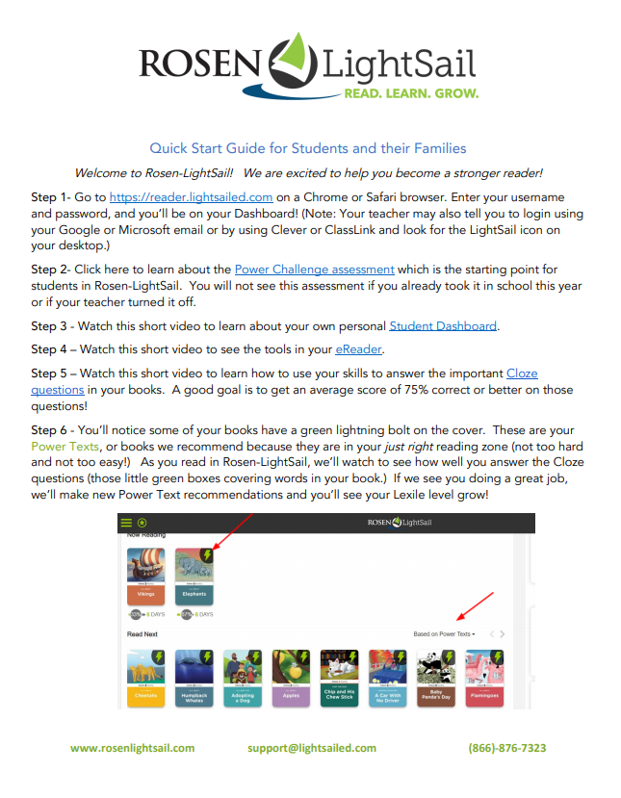

1. Go to the web-site of LightSail:

<https://lightsailed.com/school/literacy/#/login>

1. 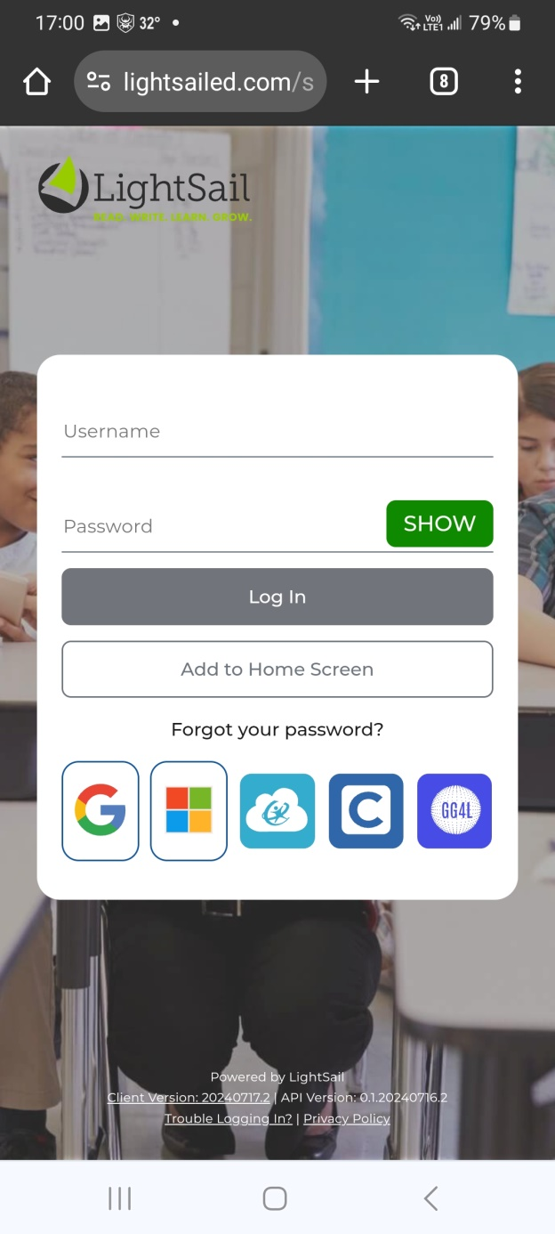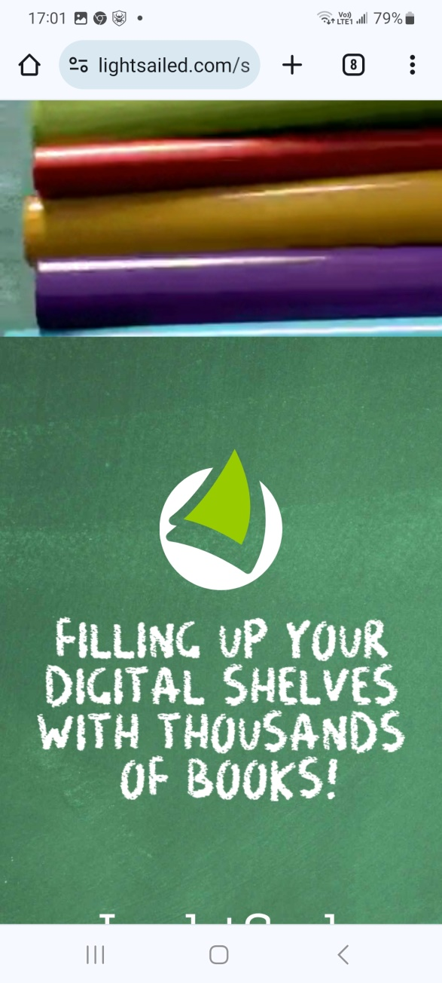 3.

e.g. b2512111

e.g. b2512111

**Username: your student number**

**Password: your student number**

4. Click the **Power Challenge Assessment** and finish the test



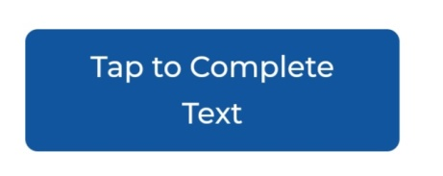5 Choose books with and start reading.

6. You can check out 2 books at a time.

7. By finishing some short response and multiple choice questions, press at the end of each book.