Baptist Lui Ming Choi Secondary School

Library Digital Resources Table (updated 01 Sept 2023)

 |  | Ways to Access | Log-in & Password
1 | LMC Library Website | https://www.blmcss.edu.hk/library/en/site/index
2. | LMC Library System (eLibrary Plus) | https://eclass.blmcss.edu.hk/home/eLearning/elibplus2/ | Log-in with eClass account
3. | HyRead (Chinese eBooks, mainly Taiwan publishers) | https://blmcsshk.ebook.hyread.com.tw/ OR  download the mobile app: HyRead HK | User login: school’s Google account  e.g. r2316031@blmcss.edu.hk  Password: lmc+ your date of birth  e.g. lmc20110325
4. | LightSail (English eBooks) | https://lightsailed.com/school/literacy/#/login | User login: Students number.:  e.g. r2316031  password: student number  e.g. r2316031
5. | SJRC (Chinese / English eBooks, mainly HK publishers) | 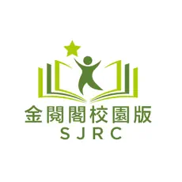  https://sjrc.club/zh-HK/loginRegister/login OR  download the mobile app: SJRC | User login: school’s Google account  e.g. r2316031@blmcss.edu.hk  Password: lmc+ your date of birth  e.g. lmc20110325

